TASK 7 – Override and Specialise Behaviour
Student Name: B. Muni Chandini
Register Number: 192524283

1. Methods that are Overridden
Method | Where Overridden | Why subclass version is needed
ratePerHour() | TwoWheeler, Car, ElectricCar | Each vehicle type has different hourly rate
toString() | Vehicle | To print meaningful vehicle information
equals() | Vehicle | Two vehicles with same registration number should be considered equal
hashCode() | Vehicle | Must be consistent with equals()
2. Use of @Override Annotation
- @Override tells the compiler that we are intentionally overriding a method.
- If we make a mistake in the method signature, the compiler will give an error.
- It is a good practice and improves code safety.
3. Rules of Overriding
- Method name, return type and parameters must be the same.
- Access level can be the same or more visible (protected → public is allowed).
- We cannot override final or private methods.
- static methods cannot be overridden (they are hidden).
4. Where final keyword is appropriate
- The field regNo is declared final because registration number of a vehicle should never change.
- We can also make a method final if we do not want subclasses to override it.
5. Why equals() and hashCode() are overridden
- By default, equals() compares memory addresses.
- In our system, two vehicles with the same registration number should be treated as equal.
- Whenever we override equals(), we must also override hashCode().
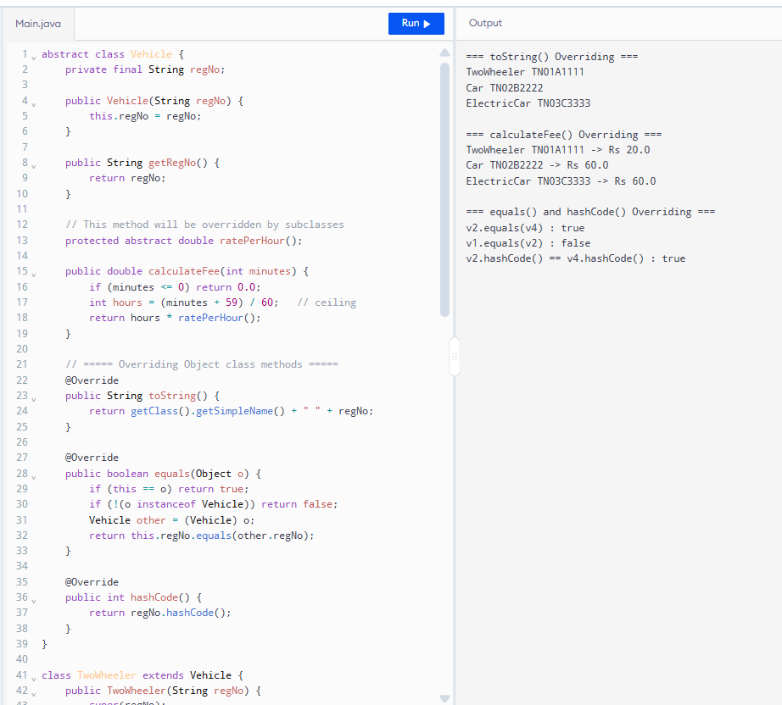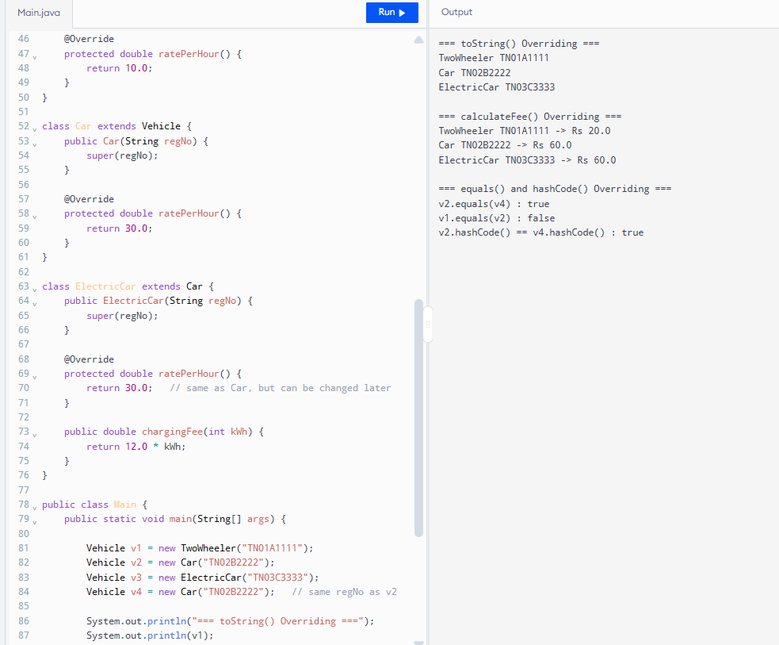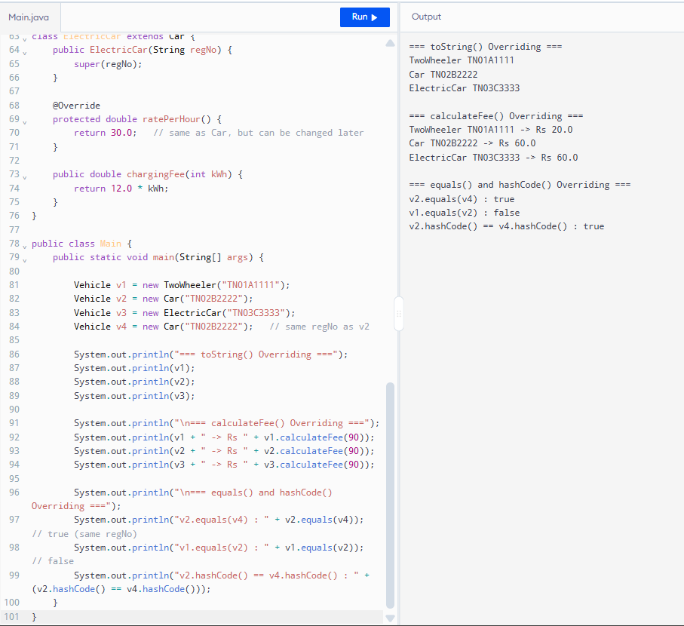
6. Alternative Concept and Complexity Analysis
Current Design: Method Overriding (ratePerHour())
Alternative: Single calculateFee() method with if-else or switch on vehicle type.
Aspect | Method Overriding (my design) | if-else / switch on type
Time complexity per call | O(1) | O(1)
Adding a new vehicle type | Just create new subclass | Must modify existing method
Number of classes to change | 0 (Open-Closed Principle) | 1 (the calculateFee method)
Code maintainability | High | Low
Conclusion:
Using method overriding is better because the system follows the Open-Closed Principle — it is open for extension (new vehicle types) but closed for modification.

